Brainstorm

& idea prioritization

# Before you collaborate

### A little bit of preparation goes a long way with this session. Here’s what you need to do to get going.

#### 10 minutes

**A Team gathering**

Define who should participate in the session and send an

**1**

# Define your problem statement

### What problem are you trying to solve? Frame your problem as a How Might We statement. This will be the focus of your brainstorm.

#### 5 minutes

**2**

# Brainstorm

### Write down any ideas that come to mind that address your problem statement.

#### 10 minutes

###### SALMAN.S

Road accidents

**NAVINASH**

Economic burdens on victim and family

**TIP**

Add customizable tags to sticky notes to make it easier to find, browse, organize, and categorize important ideas as themes within your mural.

**3**

# Group ideas

**TIP**

You can select a sticky and hit the pencil [swit sketch] icon to start dra

### Take turns sharing your ideas while clustering similar or related notes as you go. Once all

n sticky notes have been grouped, give each cluster a sentence-like label. If a cluster is bigger than six sticky notes, try and see if you and break it up into smaller sub-groups.

ote ch to wing!

#### 20 minutes

**4**

# Prioritize

### Your team should all be on the same page about what's important moving forward. Place your ideas on this grid to determine which ideas are important and which are feasible.

#### 20 minutes

**Unnamed area**

**Accurate and Fast**

**API Updates the Speed Limitations**

**Location Registration using OTP verification**

**PROBLEM**

**How might we [your problem statement]?**

# After you collaborate

You can export the mural as an image or pdf to share with members of your company who might find it helpful.

**Quick add-ons**

**A Share the mural**

Static Signboards replaced and Smart Signboards are used

Implementations of our Projects ensures easier transp[ortation without delay

Use this template in your own brainstorming sessions so your team can unleash their imagination and start shaping concepts even if you're not sitting in the same room.

**10 minutes** to prepare

**1 hour** to collaborate

**2-8 people** recommended

Smart Parking Detection

invite. Share relevant information or pre-work ahead.

###### Set the goal

Think about the problem you'll be focusing on solving in the brainstorming session.

###### Learn how to use the facilitation tools

Use the Facilitation Superpowers to run a happy and productive session.

[**Open article**](https://support.mural.co/en/articles/2113740-facilitation-superpowers)

**Key rules of brainstorming**

**An alert message to injured Person**

To run an smooth and productive session

##### Traffic Problems

Road Safety

Easy access to road condition

###### JAHANGEER NADIR KHAN

Long term physical injury

Increased Accident rate

##### Better roadways

Decreased accident rates after Installing

Traffic Maintainanace

It notifies any diversion in roads with signs

Saving on insurance cost

Better Communication Smart Signs

Maximum protection and no violation charges

Traffic congestion increases air pollution and leads to globalwarming

**Build Python Code**

Implementing our project help people know about the road condition, speed limit during

Property Damage

Traffic causes unpredictable delay and thus results in stress

Ensures safety

###### M MOHSIN KHAN

Engineering roadways with smart features including sensors that monitor and report changing road conditions and WiFi transmitters

Safety issues

Easier communication with travelers during disaster period with the installation of device

Loss of human life and money

Heavy injuries to passengers as well as

Damage to Public properties

Reduced property damage

Implementations of our projects ensures esaier transportation without delay

The risk of collision is high in wet weather

Maximum protection

**Share a view link** to the mural with stakeholders to keep them in the loop about the outcomes of the session.

**B Export the mural**

Export a copy of the mural as a PNG or PDF to attach to emails, include in slides, or save in your drive.

## Keep moving forward

###### Strategy blueprint

Define the components of a new idea or strategy.

###### [Open the template](https://app.mural.co/template/e95f612a-f72a-4772-bc48-545aaa04e0c9/984865a6-0a96-4472-a48d-47639307b3ca)

**Customer experience journey map**

Understand customer needs, motivations, and

Stay in topic.

**Divertions signs also displayed**

Defer judgment.

Encourage wild ideas.

Listen to others.

Help people to understand the

rainy or fog time

Our project will notify the

drivers

Public properties

Cost of damage will be decreased

It shows speed limit for vehicles travelling near schools or any places

Leads safer

## Importance

Report if any issue with Vehicle details

Ensures Safety

obstacles for an experience.

###### [Open the template](https://app.mural.co/template/b7114010-3a67-4d63-a51d-6f2cedc9633f/c1b465ab-57af-4624-8faf-ebb312edc0eb)

**Empathy Map**

**Weather Monitering**

**Signs According To**

**Scenarios.**

Go for volume. If possible, be visual.

To Build a Python Code

It will shows the speed limit for vehicles near Schools and other Places

road condition with easier signs

weather

condition with smart signs

will not be tranportation

disturbed

If each of these tasks could get done without any difficulty or cost, which would have the most positive impact?

###### Strengths, weaknesses, opportunities & threats

Identify strengths, weaknesses, opportunities, and threats (SWOT) to develop a plan.

|  |  |
| --- | --- |
|  |  |
|  |  |

###### [Open the template](https://app.mural.co/template/6a062671-89ee-4b76-9409-2603d8b098be/ca270343-1d54-4952-9d8c-fbc303ffd0f2)

**IOT its connected to open weather Map**

**TIP**

Participants can use their cursors to point at where sticky notes should go on the grid. The facilitator can confirm the spot by using

[**Share template feedback**](https://muralco.typeform.com/to/CiqaHVat?typeform-source=app.mural.co)

**Speed limit from web app from weather API**

Maximum Protection

the laser pointer hold

**H key** on the keyboa

ing the

rd.

[**Share template feedback**](https://muralco.typeform.com/to/CiqaHVat?typeform-source=app.mural.co)

**Feasibility**

Regardless of their importance, which tasks are more feasible than others? (Cost, time, effort, complexity, etc.)

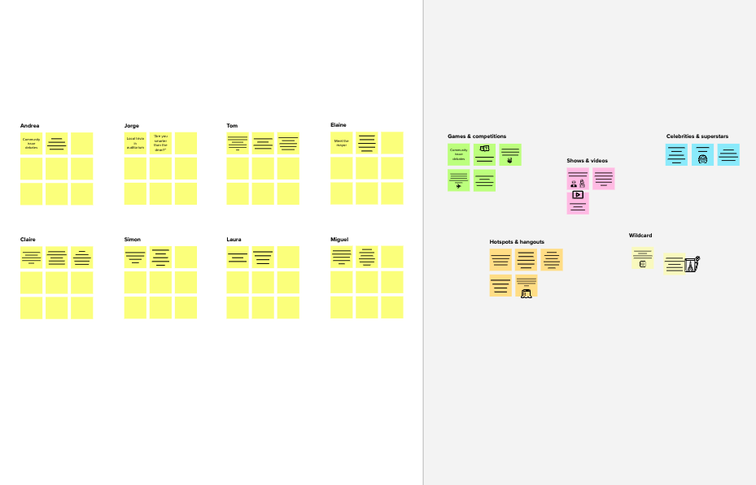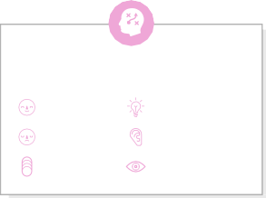

**Template**

**Need some inspiration?**

See a finished version of this template to kickstart your work.

[**Open example**](https://app.mural.co/template/e5a93b7b-49f2-48c9-afd7-a635d860eba6/93f1b98d-b2d2-4695-8e85-7e9c0d2fd9b9)